Guide 3. APT Project Final Report
Capstone Course

1. APT Project Final Report
The purpose of this report is for you to describe the most relevant aspects of your APT Project. It is important that you justify the decisions you had to make throughout the process.

Below you will find several fields that you must complete with the requested information, which account for the summary of your APT project and its main results.

Project name | Vexa Local: Intelligent Document Search and Query System through Local Generative AI (On-Premise RAG) for Organizations with Sensitive Data  Team members: Héctor Schulz (Project Manager and Full-Stack Developer), Ignacio López (Backend Developer and AI/RAG Specialist) and Josué García (Frontend Developer and UX/UI Designer). Computer Engineering, Duoc UC, Alameda campus.
Performance area(s) | • Analysis and evaluation of IT solutions  • Software development  • Cybersecurity and information risk management
Competencies | • Develop a software solution using techniques that systematize the development and maintenance process, ensuring the achievement of the objectives.  • Apply data mining and natural language processing techniques to extract relevant information from large volumes of unstructured data.  • Implement information security measures, assessing risks and applying controls that protect the confidentiality, integrity and availability of an organization’s data.

Contents of the final report
1. Relevance of the APT project | Problem and relevance for the profession  Law firms, and organizations that handle sensitive information in general, accumulate large volumes of documents (contracts, briefs, reports, records) that their professionals must consult quickly. Reviewing file by file consumes time, and cloud-based generative AI tools are not an option, because sending case files to external servers implies a risk to confidentiality and of non-compliance with regulations such as Law No. 19.628 on the protection of private life and professional secrecy. Vexa Local solves this with an AI assistant that works locally, organizes case files by case and answers by showing the sources.  The topic is relevant to the Computer Engineering job field because it integrates software development, data mining and natural language processing, and cybersecurity: three areas of the graduate profile with high demand in the industry.  Where it is located and who it affects  The situation is found in small and medium-sized organizations in Chile, in particular teams of lawyers, which do not have the budget or infrastructure for certified enterprise AI solutions. It affects case file administrators and lawyers who need to find information in extensive and varied documents, with demanding deadlines.  Value contribution (simulated)  The prototype was evaluated with synthetic documents, without real client information. It provides: (1) centralization of documents by case; (2) access control by role and assignment (a lawyer can only open cases assigned to them or to their team); (3) natural-language queries with references to the sources; (4) shorter search time, because preprocessing avoids extracting and indexing each file again; and (5) local operation, with the data on the computer itself.
2. Objectives | General objective  Design and implement an intelligent document search and query system, based on a RAG (Retrieval-Augmented Generation) architecture, that operates 100% locally, allowing organizations with sensitive data, such as a team of lawyers, to access the capabilities of generative AI without compromising the confidentiality of their information.  Specific objectives  • Select the appropriate language model, embedding and storage technologies for a local environment.  • Build an ingestion module that extracts, chunks and indexes documents (PDF, DOCX, XLSX, PPTX, TXT and CSV).  • Implement a retrieval mechanism that identifies the most relevant chunks for a query, combining lexical and semantic search.  • Develop an interface that allows administrators and lawyers to manage cases and query documents with answers and cited sources.  • Protect the information through access control, password hashing and encryption at rest, and verify that the system makes no external connections.  • Evaluate performance in terms of answer accuracy and response times using test documents and questions.
3. Methodology | Methodology used  We worked with an agile Scrum methodology combined with DevOps practices, supported by CRISP-DM for the data part. Phases and procedures:  • Understanding the problem and requirements: gathering the need raised by the team of lawyers, defining roles (administrator and lawyer) and privacy requirements.  • Design and technology selection: local desktop architecture (Electron + Flask + SQLite), model in Ollama and BM25 retrieval with optional semantics.  • Incremental development by components: ingestion, indexing, retrieval, generation with citations, interface, security and packaging; each module was tested before being integrated.  • Testing and evaluation: automated tests with pytest, functional tests with synthetic documents and privacy verification.  • Management: GitHub with GitFlow (main, develop, feature/*), Kanban board and distribution of responsibilities by role.  Relevance  Delivering functional modules in short iterations made it possible to adjust the design when technical limits arose (for example, local computation of the model) without losing direction. CRISP-DM organizes what is specific to data mining: understanding the problem, preparing documents, modeling the RAG system and evaluation. GitFlow and the distribution by roles reduced code conflicts in a team of three people with tight deadlines.
4. Development | Stages and activities  • Definition (Phase 1): problem, objectives, work plan, Gantt Chart and self-assessment.  • Environment and architecture: GitHub repository, Python environment, Ollama and component design.  • Test dataset: synthetic documents and validation questions.  • RAG engine: multi-format text extraction with optional OCR, chunking, BM25 index, vectors with bge-m3 (optional), result fusion, prompts and streaming response with sources.  • Backend and data: Flask and SQLite for users, teams, cases, deadlines and metadata; background processing with content hashing.  • Security: password hashing, roles, assignment per case, execution on 127.0.0.1, encryption of document content, 30 MB limit per file.  • Interface and desktop: administrator, lawyer and chat views in Electron, watched folder to incorporate files.  • Packaging and testing: PyInstaller and electron-builder/NSIS for Windows; tests with pytest.  Facilitators  Clear roles within the team, open-source technologies with good documentation, prior experience in Python, JavaScript and databases, and use of GitHub and Kanban to coordinate the work.  Difficulties  • Performance of the local model on computers with moderate resources; quality and speed depend on the hardware and on the relevance of the retrieved chunks.  • Dependence on Ollama: the models are not included in the installer and must be installed separately.  • Collaboration limited to a single local installation: the computers of different lawyers do not share users, cases or files.  • Partial encryption: metadata (file names, case titles) is not comprehensively encrypted.  • Pending items to close: formal documentation of the network traffic verification and consolidation of evaluation metrics.  Adjustments made  • Change from ChromaDB/Streamlit/FastAPI/Docker (initial plan) to Electron + Flask + SQLite, in order to deliver an installable desktop application.  • Hybrid retrieval: optional semantic search was added to BM25, without making it mandatory so as not to require more hardware.  • From a single PIN to users with roles and case assignment, to reflect the real work of a law firm.  • Expansion of formats (XLSX, PPTX, TXT, CSV) and optional OCR.  The limitations are explicitly stated: the system is a local prototype, not a multi-user network platform; a production version would need a central backend and database, synchronization and additional security controls.
5. Evidence | Attached evidence (appendices) that allow the stages and the final result to be followed:  • Source code on GitHub: web_app.py, store.py, vault.py, rag_hybrid.py, rag_stages.py, rag_core.py, formats.py, watcher.py and desktop/electron/main.js.  • Screenshots of the application: administrator view (accounts, teams, cases), lawyer view and chat with answer and sources.  Administrator Panel  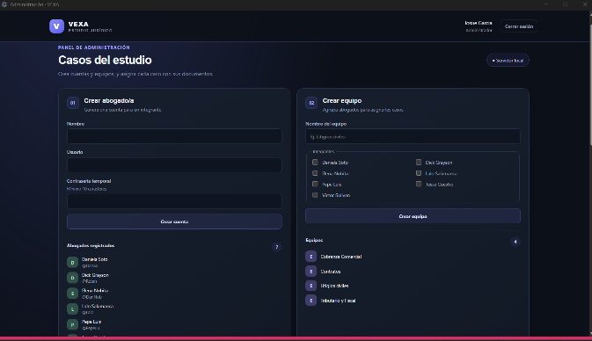  Case view;  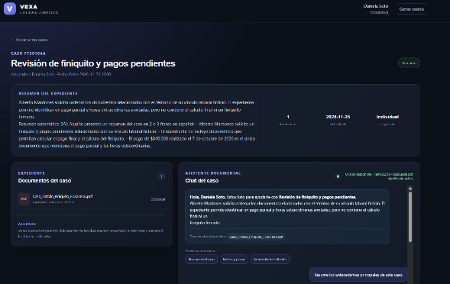  • Windows installer (PyInstaller + electron-builder/NSIS) and README with installation and usage instructions.  • Automated tests (pytest) and synthetic dataset with validation questions.  • Phase 1 and 2 documents: project definition, work plan, Gantt Chart, self-assessment, reflection journal and progress summary.  • Project presentation (Vexa Local) for the defense.
6. Professional interests and projections | Contribution of the project to my professional interests  My role was that of backend developer and AI/RAG specialist. The project allowed me to apply in a real case my strengths in web programming, desktop development and software engineering, and to work on areas that I initially identified as needing strengthening: data mining (text extraction, chunking and indexing), database programming (SQLite) and cybersecurity (access control, hashing and encryption). My interest in databases and project planning remains, and it expanded toward applied AI and information retrieval systems, which was what motivated me the most.  Career projections  I would like to continue delving into applied generative AI, RAG architectures and local models, as well as databases and IT project management. I see myself as a backend developer or developer of AI solutions that respect data privacy, and as a professional capable of evolving this type of prototype into secure multi-user platforms, incorporating a central backend, synchronization and stronger security controls.

